FMX Mobile Application Development
Lab Exercise 02.03: Creating & Connecting to a database

Creating the Database
In this training, you use the EMBEDDEDIBLITE database. Follow the steps below to create that database:
- Log on to the server as the Username of your choice
- Select Database > Create Database.
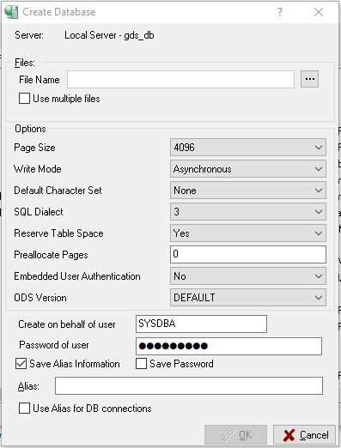
- Enter EmbeddedIBLite in the Alias field.
- Use the ... button to browse to the location for the database or enter the location into the File Name field.
- Note: In this training, we use the C:\Data\embeddediblite.ib location. You can use another location if you wish.
- Use EmbeddedIBLite.ib as the file name.
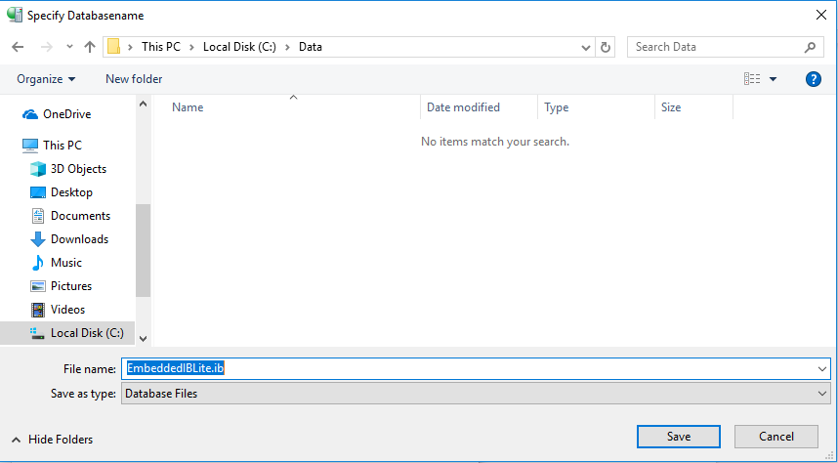

Connecting to the EmbeddedIBLite Database
To connect to the database, follow these steps:
- Select the EmbeddedIBLite database in the left pane of IBConsole.
- Choose Database > Connect.
Note: The Database Connect dialog opens automatically when you create the IBLite database.
- Enter the password for the user you are using.
- Use Connect.
Note: Use the Save Settings check box to save the credentials for the next time that you connect to this database. In order to connect as a different user, choose Database > Connect As.
- The status bar displays the name of the connected user, in this case: SYSDBA
